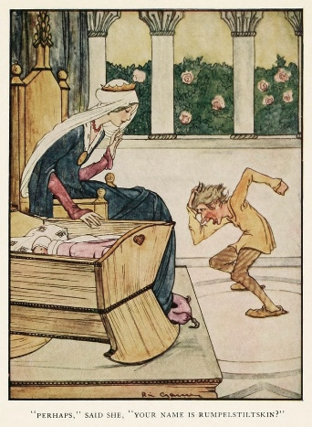
Rumpelstiltskin
Once there was a farmer who was very poor and very boastful. He had a beautiful daughter, Lisa. The farmer lied to the King about Lisa who could turn straw into gold. The King was so happy and took Lisa to the tower full of straw and a spinning wheel. The King ordered Lisa to turn the straw into gold in three days or she would die. Lisa was very sad because she could not do it. Then, a dwarf showed up and offered Lisa a help. The dwarf spun straw into gold and in return Lisa gave him her necklace and ring. The King became so greedy and wanted more gold. Then, the King asked his servant to search for all the straw in the countryside so that Lisa could turn them into gold and promised her that she would become his queen. When Lisa was sitting sadly on the floor, the dwarf showed up the third time and offered his last help to Lisa. In return, Lisa had nothing to give him. Rumpelstiltskin change the straw into gold and for a promise Lisa would give her first-born child to him after she became a queen. After a year, the King and Lisa had a baby son. The dwarf came back for the son as his reward. The queen was scared and gave him all the money she had if she could keep the child. The dwarf finally agreed to give up his reward, only if she could guess his name in three days. At first she failed, but before the final night, her parents followed the dwarf to the woods and they overheard him singing. While he was singing, they found out his name as Rumpelstiltskin. When Rumpelstiltskin came to the queen on the third day and she revealed his name, Rumpelstiltskin lost. He was so angry and stamped the floor so hard and vanished in smoke. Lisa’s father learned his lesson and promised her that he would never boast again.

七年級朗讀題目中文版大意
《侏儒怪》
一位愛炫耀的老農夫誇口說他的女兒能夠將稻草紡成金線，國王知道後，派人將老農夫的女兒帶進宮中關在塔裡，命她在三天的時間內將塔內的稻草織成金線，否則她的父親小命不保。
可憐的女孩兒正一籌莫展時，一位小矮人突然出現，宣稱願意幫助女孩兒，但要有交換條件。第一天，小矮人拿走了女孩的戒指；第二天，小矮人拿走了女孩的項鍊；到了第三天，女孩已經一無所有，小矮人於是開出條件，只要女孩把她的第一胎小孩給他，他就幫忙。女孩在情急之下只好答應。
貪心的國王看到稻草都變成了黃金，釋放了老農夫，然後開心的娶了老農夫的女兒當皇后。但就在皇后生出第一個小嬰兒時，小矮人出現了。皇后願意付出所有的財富，只求小矮人放過她的心肝寶貝。小矮人於是說，若皇后能在三天內猜出他的姓名，就放過小孩一馬。在連猜兩次都錯了之後，幸好一名僕人聽見小矮人唱的歌中有他的名字，皇后才得以答對而化解危機。氣急敗壞的小矮人據說是踩破了地板才揚長而去。

*Youtube有許多影音版的Rumpelstiltskin,詳情可參考Youtube
Rumpelstiltskin. Retrieved from http://literaturef1tof3.weebly.com/rumpelstiltskin.html , edited by Claire Huang

